Bologna Method

Introduction
Here we explain the main concepts of the Bologna method.

Definitions
The Binary rule is the rule with two agents in its left-hand part that performs the binding on these agents.
Example:
A(x, y), B(u) → A(x!1, y), B(u!1)
The Reaction is the transformation of the solution, caused by application of any rule.
The Unary reaction is the reaction, which modifies only one connected component in the solution. In other words, there are 2 injections in the left-hand part of the reaction R, both pointing to the same connected component.
The following picture illustrates the unary reaction induced by application of A(x),B(u) -> A(x!1),B(x!u):
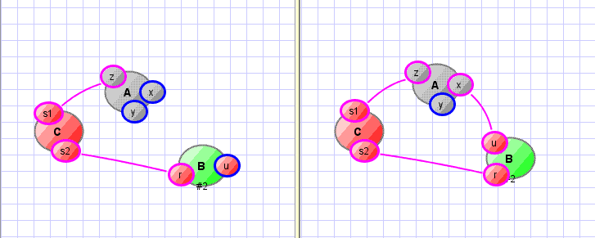
The Binary reaction is the reaction, caused by the binary rule R, which modifies two or more connected components in the solution.
The following picture illustrates the binary reaction induced by application of A(x),B(u) -> A(x!1),B(x!u):

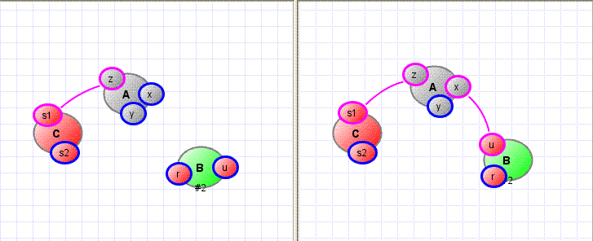
R.apply(φ, ψ) is the application of the binary rule R induced by the injection φ from the first agent and the injection ψ from the second agent.

Goal
We have the following two goals:
Goal 1: The binary reaction should have the activity calculated with the rate k2; the unary reaction should have the activity calculated with the rate k1 (that doesn't depend on the volume).
Goal 2: Prevent polymers.

Algorithm
For the rule R we have:
A(x), B(x) -> A(x!1), B(x!1) @ k1(k2), where
k1 is the rate at which unary cases should be applied;
k2 is the rate at which binary cases should be applied.

The Bologna method describes how we should apply this rule in the common case.

Calculating the activity of R
Let Φ be the set of injections from the 1st component in the left-hand part of the rule to the solution,
and Ψ be the set of injections from the 2nd component in the left-hand part of the rule to the solution.
Define k₂' = max (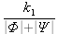, k₂).
So, instead of we compute the activity on each iteration as .
What happens if we apply R?
- Choose 2 injections to the solution from the left part of R: φ from Φ and ψ from Ψ. We have the following possible cases of φ and ψ:
a) The pair (φ, ψ) induces an unary reaction:
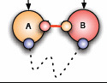
b) The pair (φ, ψ) induces a binary polymerizing reaction:
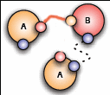
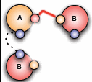
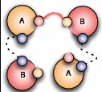
b.1 b.2 b.3
c) The pair (φ, ψ) induces a “simple” (not polymerizing) binary reaction.
- In the c) case, perform R.apply(φ, ψ) with the probability P_{inter} = and stop.
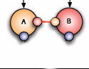
- In the b) case, swap connections in order to obtain the unary reaction:
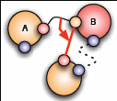
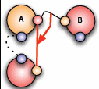
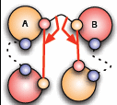
Swapping at this point obviously means changing one (φ or ψ) injection to another injection T as represented on the images. If there is more than one injection to choose from, then T is selected randomly.
- Now we want to apply some reaction. Define P_{intra} = 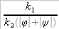.
Case b):
For the b.1 and b.2 cases we should swap the initial (black) connection with the red one and perform the obtained reaction (the creation of the red connection) with the probability P_{intra}.
For the b.3 case we should swap black connection with the left one first and try to perform the obtained reaction R1 (the creation of the left red connection) with the probability P_{intra}. If we do not succeed and reaction was not applied, then we should try to perform the reaction R2 (the creation of the right red connection) either with the probability P_{intra}.
Case a):
This is the unary reaction, the algorithm should perform it with the probability P_{intra}.
- If no reaction was applied, then the algorithm result is “reject!”, it increases time and goes on with further iterations.

Algorithm Flowchart
